***Experiment-1***

**Aim :-** Design Christmas LED chaser light.

**Apparatus:-**Connecting wires, breadboard, Arduino, LED(s).

**Circuit diagram:-** 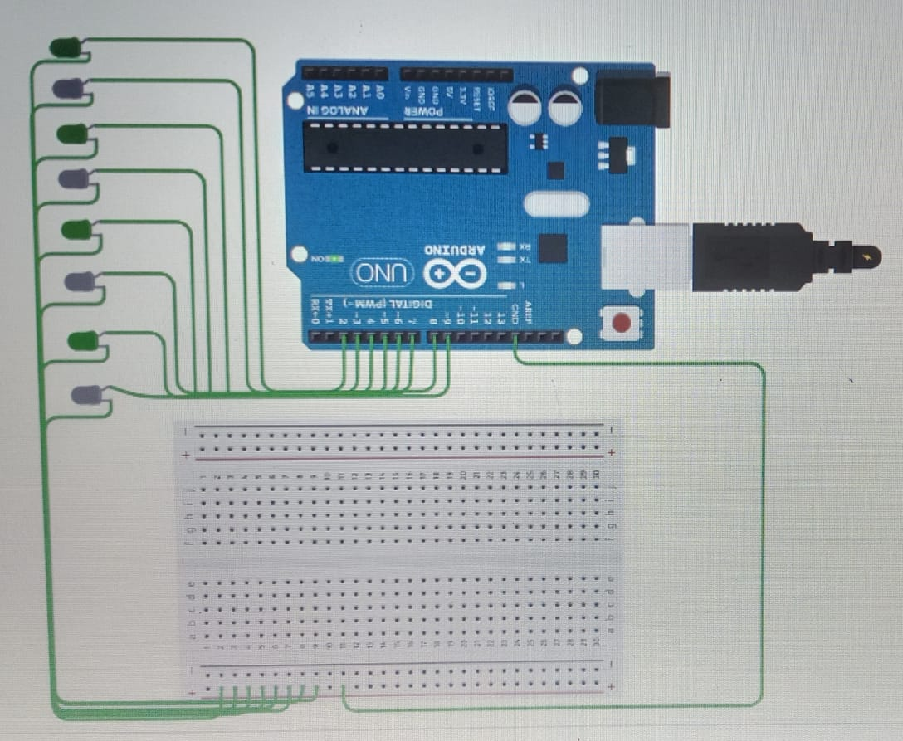

**Theory:-**

**CONCEPT:-**

**1.** Chasing of led is a pattern of led glowing using breadboard and arduino**.**

**2.** Breadboards allow components to be easily inserted and removed—therefore, the word ***prototyping*** immediately comes to mind, circuit which we want to test, a breadboard provides a cheap and quick solution.

3.  Arduino consists of both a physical programmable circuit board (often referred to as a [microcontroller](http://en.wikipedia.org/wiki/Microcontroller)) and a piece of [software](http://arduino.cc/en/Main/Software), or IDE (Integrated Development Environment) that runs on your computer, used to write and upload computer code to the physical board which is the most realible feature of it and allows to easily access any kind of pattern in led’s.

4.Digital signals provides the led’s to run the same pattern as encoded by us in IDE.

Learning and observations:-

1.This is the perfect application of how hardwares and softwares together combine and can give rise to new ideas

2. A deep analysis of the components such as arduino,breadboard,their connections,and also how programming can help to make a circuit working.

3. Working of arduino board is well explanatory ,digital and analog connections are explanatory.

4. Observation;- Before uploading the code we need to confirm that the port is properly selected ,if not code will not be uploaded and circuit will not work. The led’s will glow only if the digital signals are passed through the arduino.

5.LEARNING OUTCOMES:-

1.connections of all the components together and then a working circuit by programming the particular pattern we want to run in the circuit.

2.it helped me to enhance my coding/programming ability and developed a base of electronics using hardwares and softwares.

PROBLEMS AND TROUBLESHOOTING.:-

Port was not selected appropriately and so code was not uploaded and circuit initially did not worked.

As I tried to switch the pattern in which led’s were glowing , led’s initially were glowing in the same pattern to run the new code reset button on arduino helped to come out with such problem.

PRECAUTIONS:-

1.All the connections should be checked properly ,wires should not be loose.

2.Port should be selected properly.

3.Led should not be fused .

CODE:-

